Praneeth M V L S S S
1nt19is112

3)Use the hadoop framework to write a custom mapreduce program to perform word count operation on a custom data set.
WordCount .java
package PackageDemo;

import java.io.IOException;
import java.util.StringTokenizer;
import org.apache.hadoop.conf.Configuration;
import org.apache.hadoop.fs.Path;
import org.apache.hadoop.io.IntWritable;
import org.apache.hadoop.io.Text;
import org.apache.hadoop.mapreduce.Job;
import org.apache.hadoop.mapreduce.Mapper;
import org.apache.hadoop.mapreduce.Reducer;
import org.apache.hadoop.mapreduce.lib.input.FileInputFormat;
import org.apache.hadoop.mapreduce.lib.output.FileOutputFormat;
public class WordCount {
public static class TokenizerMapper
extends Mapper<Object, Text, Text, IntWritable>{
private final static IntWritable one = new IntWritable(1);
private Text word = new Text();
public void map(Object key, Text value, Context context
) throws IOException, InterruptedException {
StringTokenizer itr = new StringTokenizer(value.toString());
while (itr.hasMoreTokens()) {
word.set(itr.nextToken());
context.write(word, one);
}
}
}
public static class IntSumReducer
extends Reducer<Text,IntWritable,Text,IntWritable> {
private IntWritable result = new IntWritable();
public void reduce(Text key, Iterable<IntWritable> values,
Context context
) throws IOException, InterruptedException {
int sum = 0;
for (IntWritable val : values) {
sum += val.get();
}
result.set(sum);
context.write(key, result);
}
}
public static void main(String[] args) throws Exception {
Configuration conf = new Configuration();
Job job = Job.getInstance(conf, "word count");
job.setJarByClass(WordCount.class);
job.setMapperClass(TokenizerMapper.class);
job.setCombinerClass(IntSumReducer.class);
job.setReducerClass(IntSumReducer.class);
job.setOutputKeyClass(Text.class);
job.setOutputValueClass(IntWritable.class);
FileInputFormat.addInputPath(job, new Path(args[0]));
FileOutputFormat.setOutputPath(job, new Path(args[1]));
System.exit(job.waitForCompletion(true) ? 0 : 1);
}
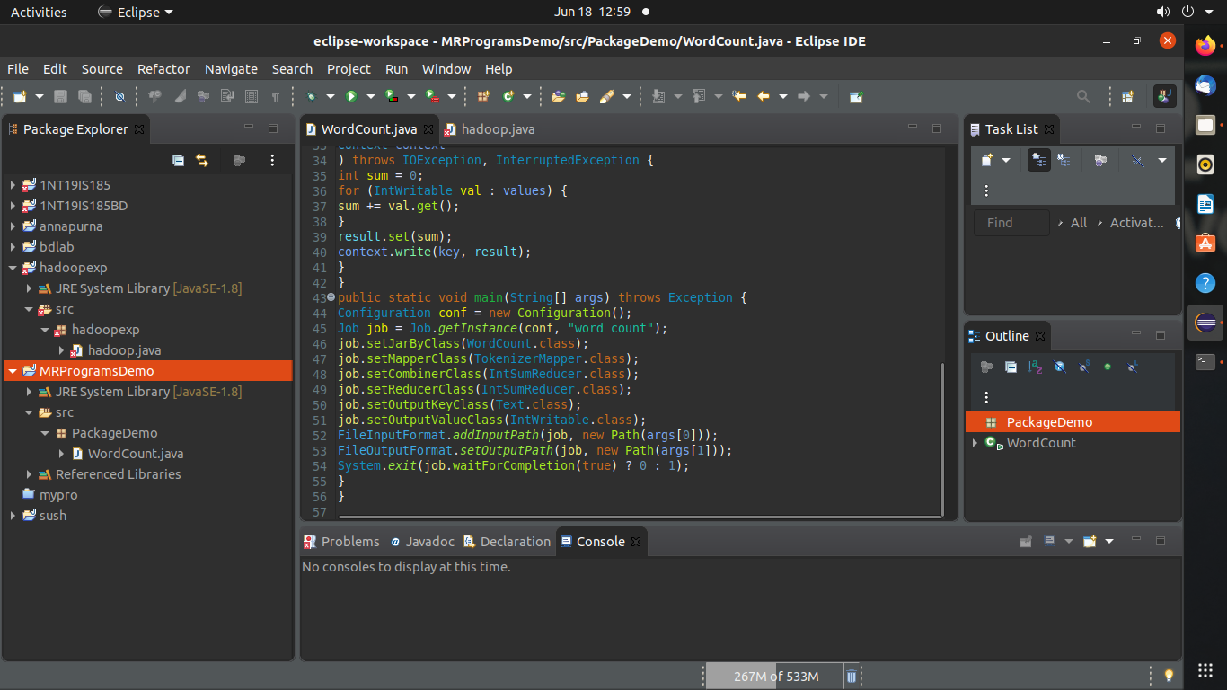
}

Terminal:
>cd $HADOOP_HOME
>cd sbin
>jps
>start-all.sh
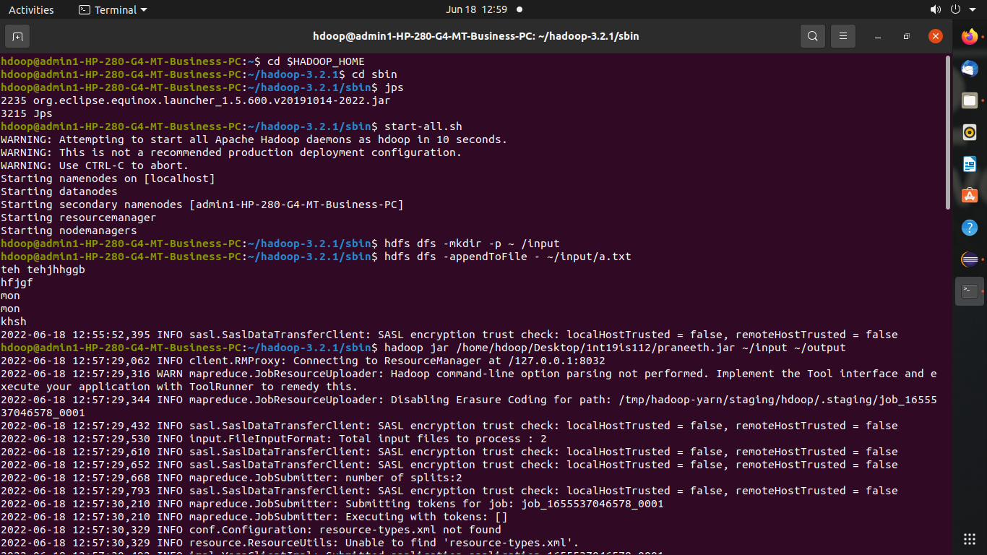

>hdfs dfs -mkdir -p ~ /input
>hdfs dfs -appendToFile - ~/input/a.txt
>hadoop jar /home/hdoop/Desktop/1nt19is112/praneeth.jar ~/input ~/output

hdfs dfs -cat ~/output/part*
